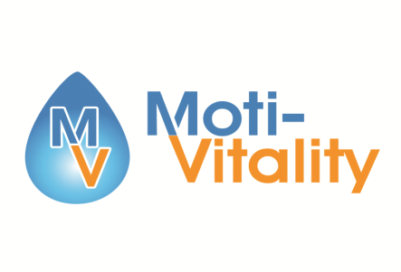

8:30-9:00 Welcome & Registration

9:00-10:20 Determining Professionalism

10:20-10:30 Break

10:30-12:00 Water Treatment Basics pt 1

12:00-1:00 Lunch

1:00-1:50 WATER TREATMENT BASICS PT 2

1:50-2:50 The anatomy of a Service Call

2:50-3:00 Break

3:00-4:30 What Women Want

**Service to Sales Mastery**